Program Information | [Lesson Title]  Let’s Go Shopping: Estimation |  |  |  |  |  | TEACHER NAME  Paula Mullet |  |  |  | PROGRAM NAME  Cuyahoga Community College
Program Information | [Unit Title]  Estimation  Life Skills  Numbers and Operations |  |  |  |  |  | NRS EFL  2 – 3 |  |  |  | TIME FRAME  180 minutes over several days
Instruction | ABE/ASE Standards – Mathematics
Instruction | Numbers (N) |  |  | Algebra (A) |  |  | Geometry (G) |  |  |  | Data (D)
Instruction | Numbers and Operation |  | N.2.9  N.3.4 | Operations and Algebraic Thinking | A.2.10 |  | Geometric Shapes and Figures |  |  |  | Measurement and Data
Instruction | The Number System |  |  | Expressions and Equations |  |  | Congruence |  |  |  | Statistics and Probability
Instruction | Ratios and Proportional Relationships |  |  | Functions |  |  | Similarity, Right Triangles. And Trigonometry |  |  |  | Benchmarks identified in RED are priority benchmarks. To view a complete list of priority benchmarks and related Ohio Aspire lesson plans, please see the Curriculum Alignments located on the Teacher Resource Center.
Instruction | Number and Quantity |  |  |  |  |  | Geometric Measurement and Dimensions
Instruction |  |  |  |  |  |  | Modeling with Geometry
Instruction | Mathematical Practices (MP
Instruction |  | Make sense of problems and persevere in solving them. (MP.1) |  |  |  |  |  | Use appropriate tools strategically. (MP.5)
Instruction |  | Reason abstractly and quantitatively. (MP.2) |  |  |  |  |  | Attend to precision. (MP.6)
Instruction |  | Construct viable arguments and critique the reasoning of others. (MP.3) |  |  |  |  |  | Look for and make use of structure. (MP.7)
Instruction |  | Model with mathematics. (MP.4) |  |  |  |  |  | Look for and express regularity in repeated reasoning. (MP.8)
Instruction | LEARNER OUTCOME(S)  - Students will estimate the cost of a group of items using several estimation techniques. |  |  |  |  |  | ASSESSMENT TOOLS/METHODS  - Students will complete Shopping Estimations Handout.  - Students will estimate the cost of a group of 10-15 items and write a short essay discussing their observations.
Instruction | LEARNER PRIOR KNOWLEDGE  - Mathematically, students should have a knowledge of basic facts (addition, subtraction), a basic understanding of place value and money.  Teacher Preparation Record the total of each receipt (to be used later).Black out the total amount of the purchase on enough receipts so each student has one. Identify the receipts (A, B, etc.), so the estimates of the cost of the items on each receipt can be compared.
Instruction | INSTRUCTIONAL ACTIVITIES  - Discuss with the students experiences they have had shopping. Have they ever not had enough cash to purchase the items they have selected to buy? Have they ever gotten home and discovered a mistake on a receipt? Encourage the class to brainstorm ways they can avoid these problems. Lead the students to the conclusion that by using estimation they could avoid these problems. Discuss how estimation can help avoid problems at the checkout because you know the approximate sum of the items you are purchasing. Explain to the students that during the next few classes they will learn estimation strategies to use while shopping.  - Give students an informal pre-test by arranging approximately 10 items with their prices marked on a table in the classroom. Give the class a minute or two to determine the cost of the 10 items. The students should not write down anything while they are looking at the items. Next, on a sheet of paper, ask the students to record their estimate of the price of the ten items. Also, ask them to briefly write down any impressions they had while making their guesses. Debrief together and discuss their answers.  - Discuss the basic strategies of estimation: front end, rounding, and grouping using the handout Estimation Basics (this handout could be made into an overhead to guide the discussion). On the chalk board, write down 5 different prices. Use front end estimation and rounding to simplify the original price. Next, estimate the sum of the 5 items. Add the price estimates of each item (found using the previous strategies), and also add the items using the grouping strategy. If needed, continue to provide the students with lists of additional prices (3-5) for which to estimate the sum. Give students an opportunity to practice estimation strategies using the handout Shopping Estimations.  Teacher Note A Teacher Resource Estimation as a tool for everyday living… is included to give you more information about estimation strategies.  - Pass out a sales receipt with the total blacked out and a copy of the Let’s Go Shopping handout to each student. Ask the students to look at the receipt and estimate the total cost of the items purchased. Remind the students that they can write down numbers if they need to, but to try to estimate the totals in their heads. When students have estimated the totals of their receipts, they should record their estimates in the appropriate line on their handout. Next students can swap their receipt with someone sitting near them. This way they can practice rounding and adding the items on another receipt. Be sure each receipt can be identified by a letter so the class can discuss their estimates for the total of each receipt.  Encourage the students to trade receipts with as many classmates as possible. Remind them to record their estimates on the handout in the column with the estimation method they used.  Teacher Note This activity can be used several different ways. First it can be done 3 times, once with each of the previously mentioned methods of estimation. You might use one estimation strategy during each class session. The students can also use all three methods of estimation with the same receipt which would be more difficult and challenging. Or the students could be told which estimation method to use for the first receipt they receive. When they swap their receipts, all the students could be told to use another method of estimation. Over the course of the lesson, the students would practice all the methods and there would be estimates for each receipt using each of the methods.  - Discuss the activity with the students. Did they have trouble estimating a total for each receipt? Did they like one method of estimating better than the others? Why? Discuss the estimates the students came up with for each receipt and record the data on a chart on the chalkboard. After the students have shared their estimates, provide the actual total of each receipt. (Or the students can use calculators to find the actual total of each receipt.) Discuss which method of estimation provided them with the closest estimate. Why? Which methods of estimation would they use again? Why? Discuss with the students other situations where they might estimate a sum (estimating the cost of a 3-course meal from a menu, etc.)  Teacher Note If the students study one type of estimation each day, be sure to collect and save their data so it can be reexamined at the end of the lesson.  - Repeat the informal pretest. Arrange 10 to 15 priced items on a table in the classroom. Again ask the students to find the approximate sum of the items. Students should record their sum for the items. Ask the students to comment on the strategies they used to find the sum. Was finding the “sum” of the items easier this time? Why? Can they think of other situations where they might estimate the sum of a number of items? |  |  |  |  |  |  |  |  | RESOURCES  Items for student estimation  Paper for student use  Student copies of Estimation Basics Handout (attached)  Student copies of Shopping Estimations Handout (attached)  Estimation…as a tool for everyday living Teacher Resource (attached)  Sales receipts for student use (1 per student) (It is helpful to have receipt with 6-8 items per receipt)  Calculators for student use  Student copies of Let’s Go Shopping Handout (attached)  Additional video resources:  Khan Academy: Rounding Whole Numbers. (n.d.). Retrieved from https://www.khanacademy.org/math/pre-algebra/order-of-operations/rounding_whole_numbers/e/rounding_whole_numbers  Baldwin, G. (n.d.). Locate benchmark numbers on a number line. Retrieved from https://learnzillion.com/lesson_plans/6250-locate-benchmark-numbers-on-a-number-line
DIFFERENTIATION

- Distribute the Estimation Basics handout to the students for reference.
- Provide highlighters to use with the handout.
- Provide additional practice with worksheets.
- Use videos to reinforce the skill of rounding.

Reflection | TEACHER REFLECTION/LESSON EVALUATION  The lesson could be made more challenging (N.3.4) by helping students round to various decimal places. Provide a chart of decimal places for students to learn this skill.
Reflection | ADDITIONAL INFORMATION  The students can practice estimation when they shop for several items. This lesson is the first of a pair of lessons on estimation. Look at Estimation with Percents for more work with estimation.

Estimation Basics

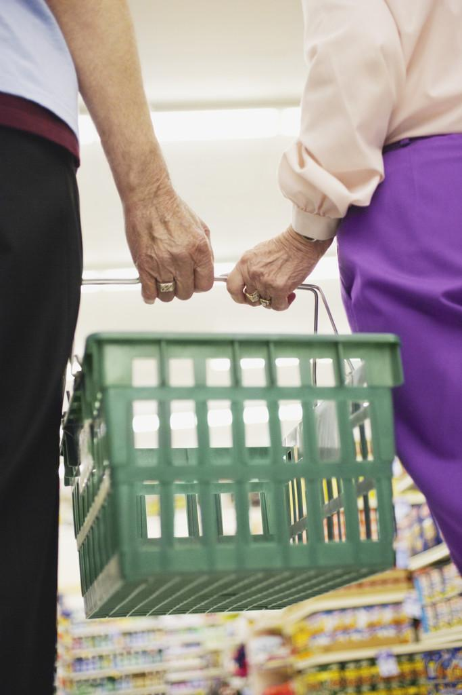
Front-End Estimation In front-end estimation, the original price/number is estimated based on the first digit in the number.
For example, the price $14.99 would be estimated at
$10. The price $3.42 would be estimated at $3. The
only number used to estimate is the first digit in the
original number.

Rounding In rounding estimation the original number is given a “second look.” The estimate is based on how close the original number is to the places on either side of the number.
For example, when rounding off $3.42 to the
nearest dollar, we must decide if the number is closer
to $3 or $4.

This is usually done by studying the place to the right of the place we are rounding off to. In this case, since we are rounding off to the ones or dollars place, we look at the tenths or 10 cents place. If the number to the right of the place we are rounding off to is 5 or more, we add one to the place we are rounding off to. If the number to the right is less than 5, the number we are rounding off to stays the same.

To illustrate this concept, I like to write the 10 digits from zero to nine on the board. Next I draw a vertical line between 4 and 5. This makes a nice visual for the students to understand how the digits divide into two groups of five: those closer to original dollar amount and those closer to the higher dollar amount.
For example $3.42 would round off to $3 since the 4 (the number to the right of the place we are rounding off to) is less than 5. The number $3.42 would be closer to $3 than $4. The number $3.72 would round off to $4 since 7 is 5 or more. $3.72 is closer to $4 than $3.
The rounded numbers become the numbers we use when we make our estimates.

Grouping When using grouping as an estimation strategy, there must be several numbers to work with. The idea of grouping is to combine two or three numbers to make a “nice” number. Usually “nice” numbers are numbers ending in a whole dollar amount or sum with an even number.
For example, if there are three prices: $11.09, $5.89 and $7.68, we might group $11.09 and $5.89 together to total $17. We would then round the third number $7.70 to $8 for a total of $25.

Estimation Basics Handout

Estimation as a tool for everyday living…

Whenever we are faced with a computation in real-life, we have a variety of choices to make concerning how we will handle the computation. Our first decision is: “Do we need an exact answer or will an approximate answer be okay?” If an exact answer is called for, we can use a mental strategy, a problem-solving procedure, a calculator or even a computer. Often, however, we do not need an exact answer and so we can use an estimate. How good an estimate – how close to the actual computation – is a matter of context.

By itself, the term estimate refers to a number that is a suitable approximation for an exact number given the particular context. This concept of an estimate is applied not only to computation but also to measures and quantities:

- Measurement estimation – using mental and visual information to measure without the use of measuring tools. For example, we can estimate the length of a room or the weight of a watermelon in the grocery store.
- Quantity estimation – approximating the number of items in a collection. For example, we might estimate the number of people at a football game or the jelly beans in a dish.
- Computational estimation – making computation easier when the answer only needs to be approximate and not exact. For example, we might want to know the approximate gas mileage in our car if we travel 326 miles on 16 gallons of gas (326 ÷ 16).

Tips for Teaching Estimation

Estimation strategies should be taught directly and discussed with students. But the best approach to improving estimation skills is to have students do a lot of estimating.

Find Real Examples of Estimation Discuss situation in which computational estimations are used in real-life. Some simple examples include dealing with grocery store situations, adding up distances in planning a trip, determining approximate yearly or monthly totals and figuring the cost of an evening out. Discuss why exact answers are not necessary in some instances and why they are necessary in others.
Use the Language of Estimation Words and phrases such as about, close, just about, a little more/less than and between are part of the language of estimation. Students should understand that they are trying to get as close as possible using quick and easy methods, but there is no correct estimate.
Use Context to Help with Estimates A real-world number sense also plays a role in estimations. Would the cost of a car more likely be $950 or $9500? A simple computation can provide the important digits, with number sense providing the rest.
Accept a Range of Estimates What estimate would you give for 27 x 325? If you use 20 x 300, you might say 6000. Or you might use 25 for the 27, noting that four 25s make 100. Since 325 ÷ 4 is about 81 that would make 8100. If you use 30 x 300, your estimate is 9000 and 30 x 320 gives an estimate of 9600. Is one of these “right”? By listing the estimates and letting students discuss how and why different estimates resulted, they can begin to see estimates fall in a range around the exact answer (8775).
Focus on Flexible Methods, Not Answers Your primary concern is to help students develop strategies for making estimates. Reflection on strategy use will lead to strategy development. For any given estimation, there are often several very good but different methods of estimation – students will learn strategies from each other. Help students learn strategies by having them use a specified approach. Later activities should permit students to choose whatever techniques they wish. Periodically discuss how different students made their estimates. This helps students understand that there is no single right way to estimate and reminds them of different approaches. Accept a range of estimates. Think in relative terms about what is a good estimate. Sometimes have students give a range of measures that they believe include the actual number. This is a practical approach to real-life and helps focus on the approximate nature of estimation. Make estimation an ongoing activity; they need not be elaborate – many times incorporating an “estimate first” component into a lesson will provide practice.

Teacher Resource

Measurement Estimation Strategies

Purpose: Using mental and visual information to measure without the use of measurement tools. For example, we can estimate the length of a room or the weight of a watermelon in the grocery store.

Techniques:

- Develop and use benchmarks for important units. Using mental benchmarks or reference points for measurement promotes multiplicative reasoning.
The width of the building is about one-fourth the length of a football field – about 25 yards.
My bed is about 7 feet long (benchmark), I could get about 3 beds in my bedroom, so this
room must be about 21 feet wide.
- Use “chunking” when appropriate. It might be easier to estimate the shorter chunks than to estimate the whole length as one.
I have 3 windows that are about 3 feet wide on a wall, with about another 3-4 feet left over, so
my wall must be between 12-13 feet.
- Use subdivisions. A similar strategy to chunking, but with the chunks imposed on the object by the estimator. Length, volume and area measurements all lend themselves to this technique.
For example, if the wall has no useful chunks, it can be mentally divided in half and then fourths or even eighths until a more manageable length is arrived at.
- Repeat a unit mentally or physically. For length, area and volume, it is sometimes easy to mark off single units visually.
You might use your hands or make marks or folds to keep track as you go.

Computational Estimation Strategies

Purpose: To make computation easier when the answer only needs to be approximate and not exact. For example, we might want to know the approximate gas mileage in our car if we travel 326 miles on 16 gallons of gas (326 ÷ 16).

Techniques:

- Front-end methods. This strategy focuses on the leading or leftmost digits in numbers, ignoring the rest. After an estimate is made on the basis of only these front-end digits, an adjustment can be made by noticing how much has been ignored.

0 + 4 + 2 = 6
about 6000

3 + 2 + 7 = 12
1200 or 1300 more

Adjust Approximation about 7300

+ | 3 | 9 | 8
4 | 2 | 5 | 0
2 | 7 | 2 | 5

B. Rounding methods. This is the most familiar form of estimation and is a way
46 x 83 =
round round
up down

50 x 80
5 tens x 8 tens
40 hundred
or
4000

of changing the problem to one that is easier to work with mentally. Good
estimators follow their mental computation with and adjustment to compensate
for the rounding. To round a number simply means to substitute a “nice” number
that is close so that some computation can be done more easily.

Teacher Resource

- Using compatible numbers (grouping). When adding a long list of numbers, it is sometimes useful to look for two or three numbers that can be grouped to make 10 or 100.

14 & 6 is 20.
The 8 & 11 (plus change) is another 20 – that’s 40 & 5 more – about $45.

Your Restaurant Bill
steak  lasagna  wine  Caesar salad  pie  pudding | $14.10  $11.50  $ 8.79  $ 6.15  $ 2.75  $ 2.00

Estimating with Fractions, Decimal and Percents

It might be argued that much of the estimation in the real-world involves fractions, decimals and percents. A few examples might be:

SALE! $51.99. Marked one-fourth off. What was the original price?
- Estimate ¾ of $51.99. To get ¾ of a quantity requires dividing by 4 and multiplying by 3. Those are whole-number computations, but they require an understanding of fraction multiplication.
About 62 percent of the 834 students bought their lunch last Wednesday. How many brought lunch?
- Deal with the 62 – close to 60 % which is 3/5 or 6 x 10% and requires whole numbers. The translation of 62% requires an understanding of percents.
Tickets sold for $1.25. If attendance was 3124, about how much was the total gate?
- An understanding of decimals and fractions converts the problem to 1 ¼ of 3125. The computations involve dividing 3125 (perhaps 3200) by 4 and adding that to 3125 – all whole-number computations.
I drove 337 miles on 12.35 gallons of gas. How many miles per gallon did my car get?
- Requires an understanding of decimals followed by whole-number calculations.

The point is that when fractions, decimals and percents are involved, an understanding of numeration is often the first thing required to make an estimate. Of course, this is not always the case for fractions and decimals. Consider: 2 3/8 + 4 1/9 – 1/12. A reasonable estimate relies almost entirely on an understanding of the numbers involved. There are very few new estimation skills required. In any good lesson involving computation of decimals, fractions and percents, estimation should certainly be part of that development.

A., V. D., Karp, K., & Bay-Williams, J. M. (2013). Elementary and middle school mathematics: Teaching developmentally. Boston, MA: Pearson.

Teacher Resource
Shopping Estimations

Estimate the sum of the following prices using
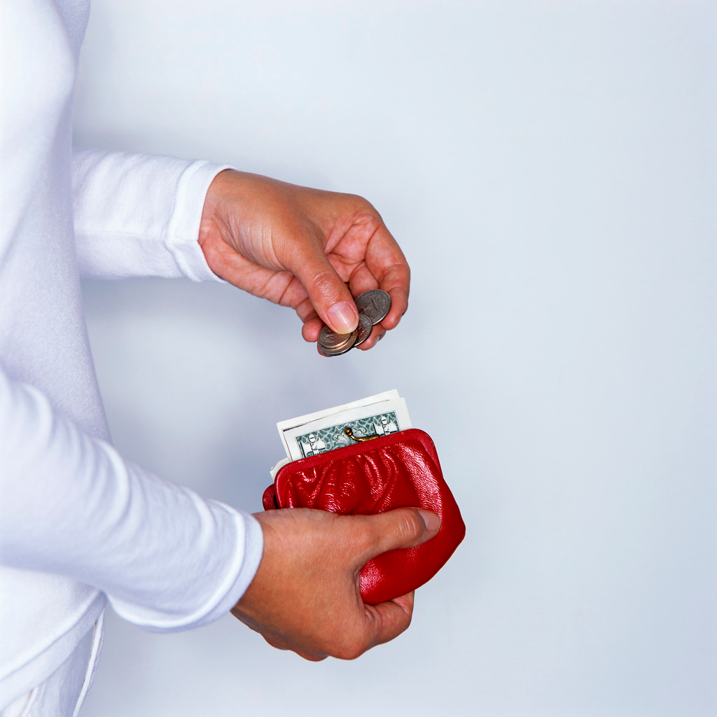

each of the following methods of estimation

$ Front-end Estimation
$ Rounding (to the nearest dollar)
$ Grouping

The boxes next to each price can be used to
write the estimate of each item. The empty
boxes at the end of each list are used to
write the totals. If desired, use a calculator
to find the actual sum of the items.

Front-end Estimation Rounding Grouping (Notes)
5.5 oz Friskies cat food $0.42
Pyrex container
$3.34
Air Freshener
$0.97
Mars Snickers 11.18 oz.
$1.99
Tootsie Roll Pops
$1.34
USB cable
$15.27
Totals

Shopping Estimations Handout
Front-end Estimation Rounding Grouping (Notes)
P.C. Wipes
$4.74
Vitamin D
$3.48
Honey
$4.39
Clay
$0.92
2 Qt. Bottle
$2.62
Lipton Tea
$4.82
Totals

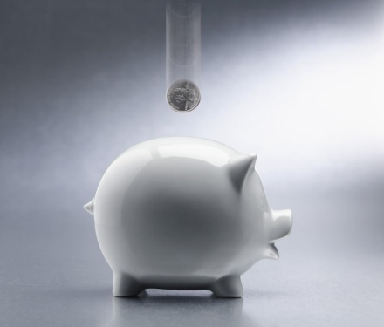

Front-end Estimation Rounding Grouping (Notes)
Crate (plastic)
$5.50
Toothpaste
$1.87
Mouthwash
$4.00
Shoe Organizer
$14.99
Face Lotion
$8.74
9 inch paper plates
$1.38
Spa Socks
$3.32
Fabric
$7.33
Totals

Shopping Estimations Handout
Let’s Go Shopping
\
Receipt | Front-end Estimation | 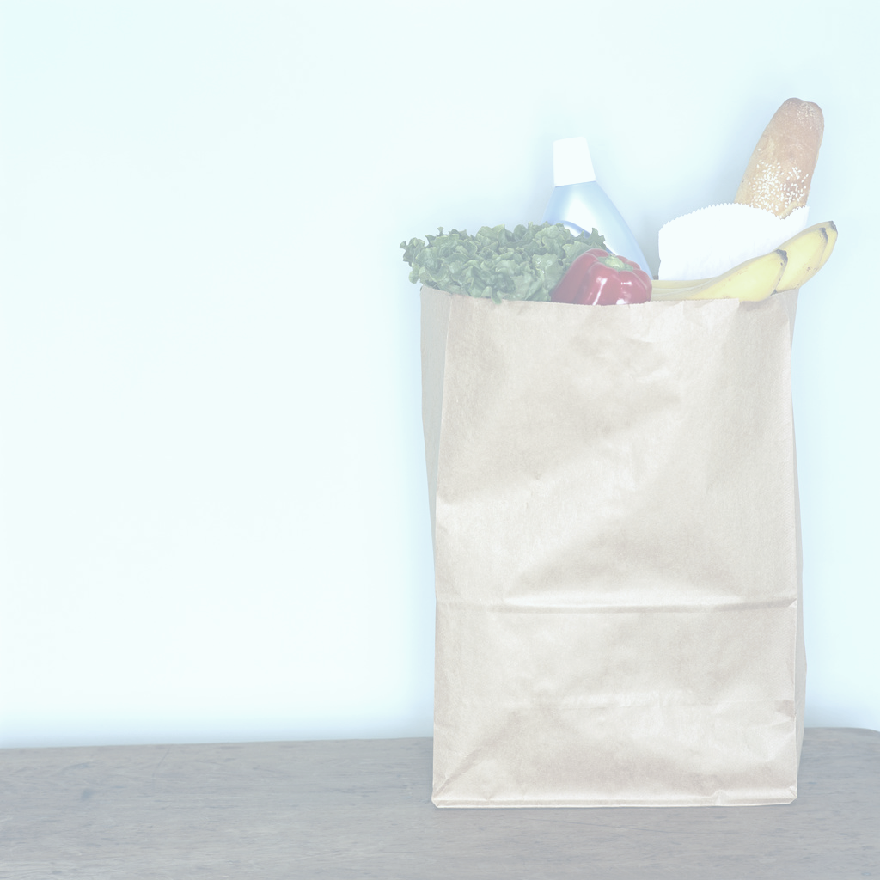  Estimation with Rounding | Estimation with Grouping | Actual Total  of the Receipt

Let's Go Shopping Handout

